Use your LOAF!
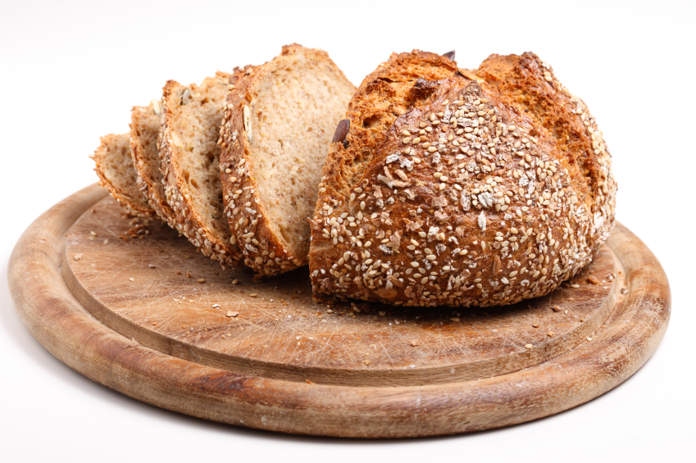
What criteria do you use when you go food shopping? Cost and quality probably come into it. But what about the ethics of your shopping sprees? The charity Christian Ecology Link suggests we use the acronym LOAF to help us remember how to eat in a way that is kinder to the earth and its inhabitants.

You probably follow some of these principles already – why not see which other ones you can use next time you shop?

Local: Try to eat mostly seasonal vegetables and fruit from the UK. We are now in the British growing season – let’s indulge in the bounty from our land! Vary your diet over the year so you can really savour that first tomato or strawberry of the summer and those first apples of the autumn. Pick your own and, for the really local, grow your own!

Organic: Organic agriculture, so long as it is grown in the UK and not transported from afar, uses less chemicals and produces fewer climate changing gases than intensive farming. It’s also the best scheme for animal welfare. The meat will be more expensive, but let that be a reason to eat less of it – for the sake of your health, and that of the planet.

Animal friendly: For some this means going vegan; for some, eating less factory-farmed produce. At least buy British – we have better animal welfare standards than other countries.
LOAFing-it is easy!
Here are some examples of LOAF ingredients:

Local, free-range eggs (A, L)
Honey, jam and fruit from West Green PYO (L)
British beet sugar (L)
Organic, UK flour (O, L)
Fairtrade chocolate, cocoa or bananas (F)
Dairy-free margarine (A) or organic butter (O)

Fairtrade: For the things we can’t grow here, coffee, tea, bananas, and, of course, chocolate, go Fairtrade for exploitation-free eating!

Have a LOAFly summer!

