Prayer guide  
for the care   
of creation

December 2018

“I am the true vine, and my Father is the vinegrower…If you abide in me, and my words abide in you, ask for whatever you wish, and it will be done for you.” (John 15. 1 and 7)

“Ask in faith, never doubting, for the one who doubts is like a wave of the sea, driven and tossed by the wind; for the doubter, being double-minded and unstable in every way, must not expect to receive anything from the Lord.” (James 1.5-8)

“Our Christian stewardship demands that we care for the whole of God’s creation, and especially for our poorer neighbours wherever they may be, remembering the words of Jesus at the end of his parable about stewardship in Luke 12.48:

“From him to whom much is given, much will be required.”

(Sir John Houghton)

“Anyone who believes in indefinite growth on a physically finite planet is either mad or an economist.”

(Sir David Attenborough)



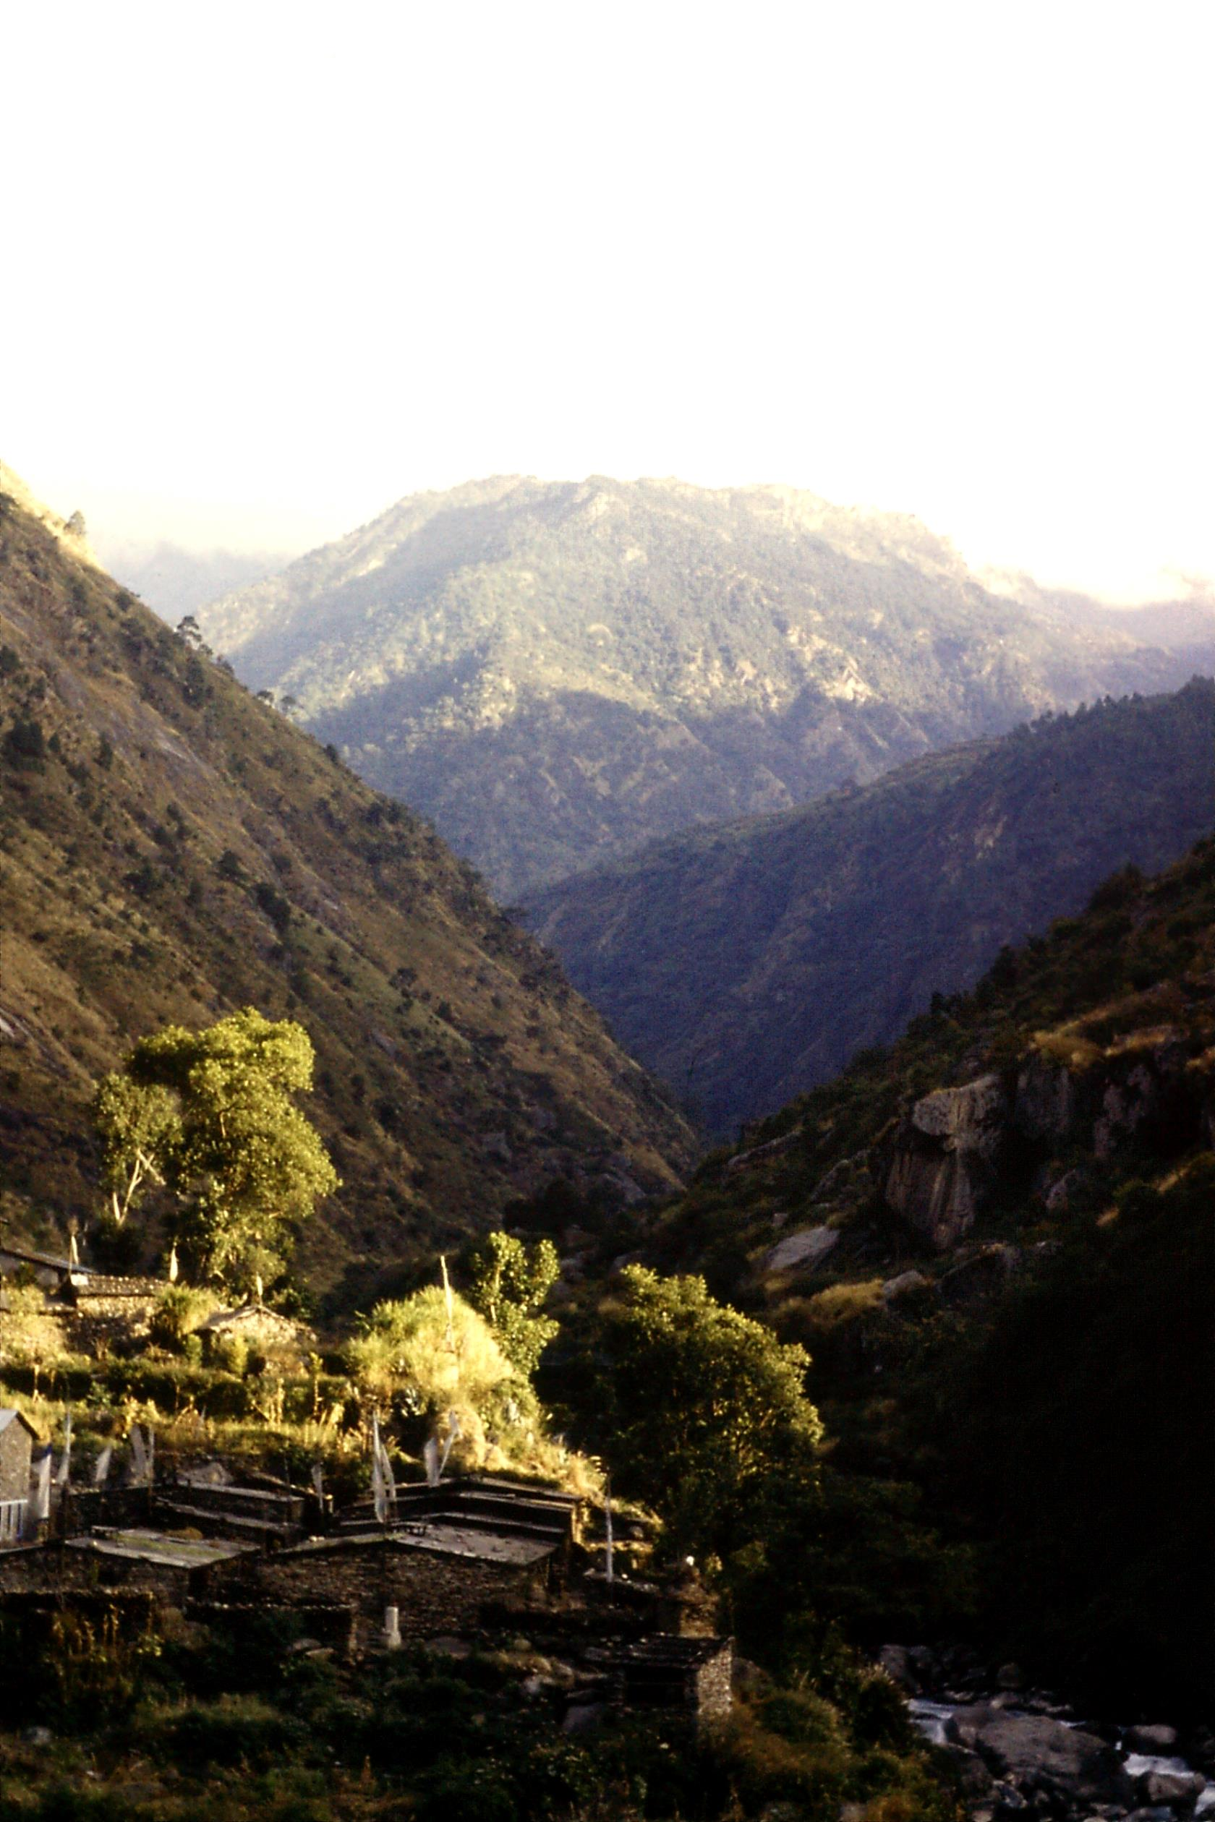

**Saturday 1st December**

From tomorrow until the 14th, the Conference of Parties (COP24) to the Paris Agreement will meet in Katowice, Poland, to decide on the next steps in implementing the Agreement. A new IPCC report has made it clear that a rise of 2°C. above pre-industrial levels would be safe for no one. Current plans to tackle climate change would see the world reaching 3 or 4 degrees above those levels within the lifetime of today's children. A rally organised by the Campaign Against Climate Change takes place today in London, beginning at noon in Portland Place and ending at Downing Street at 4 pm, with speakers from a cross-section of charity leaders and politicians.

**Sunday 2nd December**

Grant us, Father, a new vision of your world:

* A world of justice where the costs of climate change will be equitably shared between nations;
* A world of plenty where sufficient food and water will be available to all;
* A world of fairness, where success is founded on service, and honour is given to integrity alone;
* A world of peace, where order shall not rest on force, but on the love of all for this wonderful world which we all share.

**Monday 3rd December**

The Committee on Climate Change (CCC) has published a report on 'Biomass in a low-carbon economy'. Biomass includes all organic matter such as plants, soils and animals, living and dead. The Common Agricultural Policy rewards food production over other services that the land provides, such as a natural store of carbon, protection against flooding etc. A new Agriculture Bill due next year provides the opportunity to set better targets for land use. These include increased tree planting, improved forest management, restoration of peatlands and shifts to the low-carbon farming that can improve soil and water quality. These alternatives can be profitable for farmers, but the Government must provide help and training in the transition.

**Tuesday 4th December**

The CCC recommends increasing tree planting from 9,000 hectares a year to 20,000 by 2020 and to 27,000 by 2030. Energy crops should also be planted on low-quality land. Food and biodegradable waste must be collected separately from all other waste. By 2025 no biodegradable waste such as food, paper, wood, textiles and garden waste should be sent to landfill.

**Wednesday 5th December**

In order to ensure that imported biomass comes from sustainable sources, the UK must lead a global shift towards improved monitoring of biomass stocks, using satellite data. There should be a substantial increase in the use of wood in buildings, while biomass plants that do not capture and store their emissions must be phased out. The use of biofuels in cars and vans should be phased out in the 2030s, while there should be support for the use of biofuels in aviation.

**Thursday 6th December**

Summing up the report, the CCC Chairman, Lord Deben, said: “Land is our most precious natural asset, but the way we use it needs fundamental reform. We must ensure our use of land helps to reduce the emissions that are warming our atmosphere. . . We need a new conversation about the role that biomass can play in helping to meet the UK's climate change targets. If supply of biomass is more strictly governed, its use can be sustainable and it can play an essential role in reducing emissions and locking away carbon in plants and soils.”

**Friday 7th December**

A report from WWF suggests that a target for a zero-emission Britain by 2045 is possible, provided changes in industry, energy and lifestyle are rolled out nationwide. Under this plan, shipping must cut its emissions by at least 70% by 2050, industry by 90% and there must be no further growth in aviation emissions from today's levels. In addition, a large roll-out of options for removing greenhouse gases will be essential, from afforestation to carbon capture technology. “A change in diet, away from red meat and towards more plant-based eating, would be necessary to meet the 2045 deadline. Halving UK meat consumption could save roughly 10 megatonnes of CO2 equivalent a year, so reducing the burden of emission cuts on farmers.”

**Saturday 8th December**

Religious leaders from the Christian, Jewish, Sikh, Hindu, Muslim and Buddhist faiths have sent a letter to the Prime Minister raising concerns about the UK's growing obesity rates, food bank use and rising tension over immigration, and pointing to the UN Sustainable Development Goals (SDGs) as an opportunity to build a more sustainable, healthy and inclusive national community. “Only 24% of the SDGs are on track to be achieved in the UK by 2030.” The letter urges Theresa May to appoint a minister dedicated to achieving the SDGs as part of efforts to address poverty, inequality and environmental stresses.

**Sunday 9th December**

Loving Father, you sent your Son to be a light to those who walk in darkness. Enable us who have brought your creation, the land, the water, the creatures and our own selves to the edge of darkness, to see the new path that we must now tread, through the power of your Son, Jesus Christ.

**Monday 10th December**

A study of more than 2,000 schoolchildren in London, published in the *Lancet*, found that pollution from diesel vehicles was stunting the growth of their lungs, leaving them damaged for life. An increasing number of parents were shunning good schools because of the local air quality, while some were even looking to move out of cities altogether. Sarah MacFadyean of the British Lung Foundation said: “We know now for sure that air pollution is a causative factor in lung cancer for people with a lung condition. It puts them at greater risk of attack. New papers are coming out linking air pollution to different types of cancer, to diabetes, Alzheimer's and obesity.”

**Tuesday 11th December**

The Nissan Leaf electric car has won approval from German regulators to act as a mobile battery backstop, so that power can flow from the grid to the car when it is charging, but also from the battery back to the grid when required. This service can help stabilise the power grid and minimise its peaks and troughs, while providing a source of income for Leaf owners. Nissan is experimenting with a similar system, known as V2G, in the UK in partnership with Ovo Energy, and is the lead partner in a Government project to instal 1,000 V2G charge points for business fleets.

**Wednesday 12th December**

Fourteen renewable energy companies including SSE, Scottish Power, Vattenfall and Siemens, have written to the Business Secretary urging the Government to support the low-cost energy available from new wind farms and lift the block on onshore developers competing for clean energy contracts. Plummeting development costs mean that the sector could bid for new projects at below wholesale prices, so making them subsidy-free. “Delivering onshore renewables would help the UK meet its carbon goals and curb costs for consumers who are currently subsidising more expensive forms of clean energy.”

**Thursday 13th December.**

Heavy fossil fuels used in ships are even more polluting than those used in land-based vehicles as they emit sulphur and other contaminants. Now Norwegian cruise line Hurtigruten aims to convert 6 of its 17 vessels to use biogas made from waste from the fishing industry combined with liquefied natural gas and large battery packs, capable of storing electricity generated from renewables. The daily greenhouse gas emissions from the world's large cruise liners can be as great as those from one million cars. Now, new battery technology makes it possible to install batteries big enough to last a voyage without the need to recharge them.

**Friday 14th December**

'Single-use plastics' have rightly become dirty words as consumers increasingly dump pointless plastic packaging at supermarket checkouts. Our power as consumers is certainly important, but the major decisions on how we eliminate non-recyclable plastic waste from our lives rests with the Government and the companies that produce the plastics. If we are to protect our oceans and future generations from increasing plastic pollution, the Government must tax its production and set firm targets for year-on-year reduction of single-use plastics.

**Saturday 15th December**

A report from Greenpeace and the Environmental Investigation Agency finds that the ten leading supermarkets alone produce at least 59 billion pieces of plastic a year. Five of them – Aldi, the Co-op, Sainsbury's, Tesco and Waitrose – have no targets for reducing plastic packaging. The targets of others are so low that it would take them 20 years to rid their shelves of throwaway plastic. Yet a recent poll showed that 86% of shoppers support the idea of supermarkets using more refillable and reusable packaging. Morrison's is leading the way on refillable packaging, but there is an urgent need for all supermarkets to upgrade their policies on the roll-out of reusable packaging.

**Sunday 16th December**

Loving Father, we cannot of ourselves bring about the changes in human behaviour that are now required of us if we are to meet the challenges climate change and pollution, but help us to start where we are. Make us honest and just in all our dealings, outspoken but wise in all our words and actions. We cannot alter the course of a suffering and unjust world, but help us to light candles in the darkness, in the Name of Jesus Christ, who came to bring light to our darkness.

**Monday 17th December**

A report from the UN Population Fund highlights the decline in human fertility since 1950, with exceptions in Sub-Saharan Africa and the Indian subcontinent. However, global population continues to grow by 80 million a year and the impact of that growth on the health of our planet is profound. Falling fertility and greater longevity leads to an ageing population, which is sometimes seen as a threat, yet simply adding more young people to tackle an ageing population is doomed to fail, simply because those people themselves become old and the result is an infinite spiral of population growth.

**Tuesday 18th December**

A 2017 paper signed by more than 20,000 scientists declares that unsustainable population growth is a primary driver of our current environmental crisis including climate change. The World Scientists' Warning to Humanity calls for action to reduce population growth, including better education for women and girls and provision of high-quality family planning for all who need it. Meanwhile humanity is consuming the resources of 1.7 Earths, with that number set to rise to 3 Earths by 2050 unless population and consumption trajectories are radically changed.

**Wednesday 19th December**

'Total Fertility Rate' (TFR) means the number of children an average woman is expected to have during her child-bearing years. In 1950, the world's average TFR was 4.7. It is now 2.4. However, over the same period global population has tripled, for two reasons;

1. People are living longer
2. Past high TFR rates lead to high levels of people of child-bearing age a generation later. The number of children per family goes down, but the number of families continues to rise. Hence the UN predicts that global population will continue to rise to 11 billion, while it is currently 7.6 billion.

**Thursday 20th December**

A new report from Population Matters shows that while an additional 46 million women have taken up modern contraceptives since 2012, if the UN were to meet its targets, another 74 million would have to start using family planning by the end of 2020. This is because the number of women of reproductive age has risen from 834 million in 2012 to 924 million now. Half of this population growth has taken place in Bangladesh, Ethiopia, India, Nigeria and Pakistan.

**Friday 21st December**

The Energy Transition Committee, backed by 200 industry leaders, claims that global carbon emissions could come down to 'net zero' by 2060 by tackling pollution from transport, aviation and manufacturing alone. Cutting emissions to this degree can be made at a cost of just 0.5% of global GDP by mid-century, and this could be reduced even further by improved energy efficiency. Lord Adair Turner, its co-chairman, said: “We can build a zero-carbon economy with a minor cost to economic growth. We should now commit to achieving this by 2060 at latest, and put in place the policies and investments required to deliver it.”

**Saturday 22nd December**

Last month the 25 nations of the Antarctic Ocean Commission (AOC) meeting in Hobart, failed to establish an ocean sanctuary, leaving the area exposed to increasing pressure from overfishing, pollution and climate change. However, a global ocean treaty is on the table at the UN which, if approved, would open the door to creating new protected areas covering at least one-third of the world's oceans. Since 22 of the 25 nations on the AOC supported the creation of an Antarctic Ocean Sanctuary, there are great hopes that a new UN treaty would command widespread support.

**Sunday 23rd December**

Lord Jesus, the carpenter, help us not to be afraid to get our hands dirty as we work in your Name. Challenge us every day to care for your world, and always to work gently for it.

**Monday 24th December.**

Gracious heavenly Father, our Creator and Sustainer, we thank you today for that little Child who would make us all your children. As we remember his lowly, humble birth, take away all our pride. As we remember his pure life, take away our sins. As we remember how he came, not to be served, but himself to serve, help us to strive more unselfishly, to give more generously and to love more devotedly. (Leslie Weatherhead – adapted)

**Tuesday 25th December**

Loving Father, as we ponder the coming of the child of Bethlehem, we rejoice that you. the Almighty, the Creator, the Infinite, whose being is utterly beyond our loftiest thought and most daring imagination, can speak to us as a little Child. Save us from being over-impressed by the impressive. Help us to see you in simple things: a child's trust, birdsong, the quiet loveliness of dawn, human friendship and the peace of our homes. We bow in worship before the majesty of heaven revealed in a human life. Accept our worship and make us more like your dear Son, who gave of himself, not counting the cost. (Leslie Weatherhead)

**Wednesday 26th December**

The Government has published an Agriculture Bill which will enable the use of public money for landowners to deliver environmental benefits such as soil health, wildlife protection and public access. It will over the period 2021-2027 replace the current system of payments for the amount of land owned. Graeme Willis of CPRE said: “Paying farmers for protecting and enhancing our landscapes, soils and countryside is a good step towards restoring our environment, producing food more sustainably and ensuring our countryside is thriving in years to come. It's great to see the Government rewarding farmers for environmental stewardship, but there must also be measures to reverse the decline in smaller farms.”

**Thursday 27th December**

CPRE's annual State of the Green Belt report finds that 400,000 houses are planned for building on Green Belt land, but that 72% of the houses already built on Green Belt land were unaffordable by the Government's own definition. There is currently enough brownfield land to accommodate more than a million homes, while local authorities with Green Belt land have enough brownfield sites for over 720,000 homes. The revised National Planning Policy Framework requires local authorities to fully examine alternatives to releasing Green Belt land. Any changes to GB boundaries must be fully evidenced and justified. CPRE calls on the Government to develop clear guidance for local authorities on their requirements to protect designated land.

**Friday 28th December**

The National Infrastructure Commission has received Government approval for its plan to develop an 'Oxford-Cambridge Arc' which would include 1 million new homes by 2050 and a new 'Expressway' linking the two cities. CPRE comments: “Any development in the Arc must go through the proper planning process, with local involvement and commitments to affordable housing, high quality design and environmental protection. It must be built around improvements to public transport, not a new road that will lock in carbon emissions, air pollution and car dependency for decades to come. We propose that the 3.5 billion pounds earmarked to build the expressway alone would be better invested in more sustainable initiatives such as the restoration of East-West Rail.”

**Saturday 29th December**

According to CPRE, the development would involve the loss of 27,000 hectares of greenfield farmland – an area the size of Birmingham - in one of the most water-stressed districts of England. Historic England says that the development would involve the loss of 205 scheduled monuments, 144 conservation areas (29 of them in Oxford and Cambridge), 7,321 listed buildings, 48 historic parks and gardens plus the Blenheim Palace World Heritage Site.

**Sunday 30th December**

Father, whose patient ways with us and whose unfailing love surprise and humble us, go with us along the unknown paths of this New Year. Forgive the sins of the past. Help us to live more worthily and to serve you more faithfully, so that our lives may show forth a new beauty and a deeper harmony, so that your holy Name may be glorified throughout the world.

**Monday 31st December**

Lord God, who changes not with the passing years, we, the creatures of Time, look back along the road we have come. We thank you for all your loving kindnesses and tender mercies along the way. When the road has been dark, you have not failed us, though we have often failed you. We look forward, knowing not what may befall us in the year ahead. Help us to live each day at a time, and to trust you as much in the shadow as in the sunshine. Go with us, we pray, into this New Year and bring us through it safe in the knowledge that we have been faithful followers of your Son, who is the Way, the Truth and the Light. Amen.

(Leslie Weatherhead)

Sources:

* Fieldwork (CPRE)
* Population Matters
* www.greenpeace.org.uk
* www.businessgreen.com
* www.theccc.org.uk

If you would like to receive the prayer diary each month by email (free), please email:

[prayer-guide@greenchristian.org.uk](mailto:prayer-guide@greenchristian.org.uk)

For further information and requests for prayer, please write or email:

Philip Clarkson Webb,

15 Valley View,

Southborough,

Tunbridge Wells TN4 0SY

Email: [pcw@greenchristian.org.uk](mailto:opcwebb@tiscali.co.uk)

Website: [www.greenchristian.org.uk](http://www.greenchristian.org.uk)

Picture on front cover: The Langtang Valley, Nepal

Green Christian is a Trading name of  
Christian Ecology Link Ltd.  
Correspondence Office:  
10 Kiln Gardens, Hartley Wintney,   
Hampshire, RG27 8RG, UK.  
Company Registration No. 2445198  
Registered Charity No. 328744.  
tel: +44 (0) 345 4598460  
info@greenchristian.org.uk 